**WEB-BASED E-SHOP**

**by**

**S.M. Samrat**

**ID: 191-15-12300**

**AND**

**Shafiqul Islam**

**ID: 191-15-12226**

This Report Presented in Partial Fulfillment of the Requirements for the Degree of Bachelor of Science in Computer Science and Engineering

Supervised By

**Sharmin Akter**

Lecturer

Department of CSE

Daffodil International University

Co-Supervised By

**Ms. Nazmun Nessa Moon**

Assistant Professor

Department of CSE

Daffodil International University



**DAFFODIL INTERNATIONAL UNIVERSITY**

**Dhaka, Bangladesh**

**December 2021**

**APPROVAL**

This Project titled “**Title**”, submitted by *Name1* and *Name2* to the Department of Computer Science and Engineering, Daffodil International University, has been accepted as satisfactory for the partial fulfillment of the requirements for the degree of B.Sc. in Computer Science and Engineering and approved as to its style and contents. The presentation has been held on *date*.[**Font-12**]

**Board of Examiners**

**(Name)** [**Font-12, Bold**] **Chairman**

**Designation**

Department of CSE [**Font-12**]

Faculty of Science & Information Technology

Daffodil International University

**(Name) Internal Examiner**

**Designation**

Department of CSE

Faculty of Science & Information Technology

Daffodil International University

**(Name) External Examiner**

**Designation**

Department of -------

Jahangirnagar University

**Declaration**

We hereby declare that, this project has been done by us under the supervision of **Sharmin Akter, Lecturer, Department of CSE** Daffodil International University. We also declare that neither this project nor any part of this project has been submitted elsewhere for award of any degree or diploma.

**Supervised by:**

**Sharmin Akter**

Lecturer

Department of CSE

Daffodil International University

**Co-Supervised by:**

**Ms. Nazmun Nessa Moon**

Assistant Professor

Department of CSE

Daffodil International University

**Submitted by:**

**S.M. Samrat**

ID: -19-15-12300

Department of CSE

Daffodil International University

**Shafiqul Islam**

ID: -191-15-12226

Department of CSE

Daffodil International University

**ACKNOWLEDGEMENT**

First we express our heartiest thanks and gratefulness to almighty God for His divine blessing makes us possible to complete the final year project/internship successfully.

We really grateful and wish our profound our indebtedness to **Sharmin Akter**, **lecturer**, Department of CSE Daffodil International University, Dhaka. Deep Knowledge & keen interest of our supervisor in the field of “*Field name*” to carry out this project. His endless patience ,scholarly guidance ,continual encouragement , constant and energetic supervision, constructive criticism , valuable advice ,reading many inferior draft and correcting them at all stage have made it possible to complete this project.

We would like to express our heartiest gratitude to **Sharmin Akter**, **Ms. Nazmun Nessa Moon** andHead**,** Department of CSE, for his kind help to finish our project and also to other faculty member and the staff of CSE department of Daffodil International University.

We would like to thank our entire course mate in Daffodil International University, who took part in this discuss while completing the course work.

Finally, we must acknowledge with due respect the constant support and patients of our parents. [**Font-12**]

**Abstract**

Nowadays, people are interested in shopping online. So , the website that crates the web-based e-shop. This e-shop project is also client friendly and helpful for consumers.

Online Shopping plays a better importance in the modern business environment. Our e-commerce shop provide online web based shopping system. our project purpose is distribute online shopping system to web space platforms. This project provide online shopping facilities to the customers in real time. Every customers buy a product by using mobile through the internet to home. Thus customers will get online shopping services from the house of their choice. This project system can implement in locality area shop. This application get any time and easily accessible as this is available on android phones.

Successful design and implementation of an e-commerce website require appropriate strategies. Everything from scratch to the end of the website needs to be planned. The e-commerce sector is showing indicative growth so a new alternative would easily be part of this regatta of commercial websites. E-commerce means providing online shopping facility under web space

**TABLE OF CONTENTS**

|  |  |
| --- | --- |
| **CONTENTS** | **PAGE** |
| Board of examiners | i |
| Declaration | ii |
| Acknowledgments | iii |
| Abstract | iv |
| **CHAPTER** |  |
| **CHAPTER 1: INTRODUCTION** | **1-4** |
| 1.1 Introduction ……………………………………………………………….. | 1 |
| 1.2 Motivation ………………………………………………………………....  1.3 Objectives…………………………………………………..……………...  1.4 Expected Outcomes.……………………..………………………………..  1.5 Report Layout ……………………………………………………………..  **CHAPTER 2:**  **BACKGROUND**  2.1 Preliminaries/Terminologies…..…………………………………………..  2.2 Related Works…………………………………………………..................  2.3 Scope of the Problem………...……………………………………………  2.4 Challenges……………………………………….…………………………  **CHAPTER 3:**  **REQUIREMENT SPECIFICATION**  3.1 Business Process Modeling……………..………………………………..  3.2 Use Case Modeling and Description………….…………………………...  **CHAPTER 4: DESIGN** **SPECIFICATION**  4.1 Front-end Design…………………………………………………………..  4.2 Back-end Design…………………..………………………………………  4.3 Interaction Design and User Experience……..…………………………...  4.4 Implementation Requirements………………..…………………………...  **CHAPTER 5:** **IMPLEMENTATION and TESTING**  5.1 Implementation of Database ……………………………………………...  5.2 Implementation of Front-end Design……………………………………...  5.3 Testing Implementation & Results………………………………………...  **CHAPTER 6:IMPACT on SOCIETY, ENVIRONMENT and SUSTAINABILITY**  6.1 Impact on Society……….. …………………………………..…………...  6.2Impact on Environment ………………………………………...................  6.3 Ethical Aspects……………………………………………………...…….  6.3 Sustainability Plan…………………………………………………………  **CHAPTER 7:**  **CONCLUSION & FUTURE SCOPE**  7.1 Discussion and Conclusion ……………………………………………….  7.2 Scope for Further Career…………………………………….…………..... | 2  3  3  4  5-7  5  6  6  7  8-9  8  9  10-19  10  16  19  19  20-26  20  21  24  27-28  27  27  28  28  29  29  29 |

**LIST OF FIGURES**

|  |  |
| --- | --- |
| **FIGURES** | **PAGE NO** |
| Figure 3.1 : BPM | 8 |
| Figure 3.2: E-shop Use case | 9 |
| Figure 4.1: Front-End Design | 11 |
| Figure 4.1.1: Log-in Page | 12 |
| Figure 4.1.2: Sign up Page | 13 |
| Figure 4.1.3: Customer products cart list | 14 |
| Figure 3.1.4: Customer orders pending list | 15 |
| Figure 4.2: Admin panel | 16 |
| Figure 4.2.1: Add to product in Back-end | 17 |
| Figure 4.2.2: Add a category in Back-end | 18 |
| Figure 4.2.3: Add order in Back-end | 18 |
| Figure 5.1: Database | 20 |
|  |
|  |  |
|  |  |

**CHAPTER ONE**

**INTRODUCTION**

* 1. **Introduction**

This e-shop project is web based shopping system. Our main objective is to deliver the product to the customer's home. the customers can buy a product directly from store seller without a mediator through the internet. This is an online electronic shopping platform. Our e-shop project gives an online shopping opportunity to consumers. Every customer can buy a product using a smartphone through the internet in house. Thus customers will get online shopping services from the house of their choice. Successful design and implementation of an e-commerce website require appropriate strategies. Everything from scratch to the end of the website needs to be planned. The e-commerce sector is showing indicative growth so a new alternative would easily be part of this regatta of commercial websites. E-commerce means providing online shopping facility under web space. The dell web site will permission business people to use it to do their total business and increase their accessibility through the internet a thousand times more than today. This will allow multiple shoppers to sell their products online. Product management in the system will be done in the form of a department. The main requirements of the data security system and will be managed accordingly. The first step in formulating this project is to estimate the cost.

* 1. **Motivation**

There is a reason behind everything in this world. Most of which have been invented

There are some kinds of problems for human beings in this world. Our application solves some of the main problems we have identified when using an international online e-commerce websites.

1. Availability Shopping Card: Maximum number of public is an intermediary and minor class into Bangladesh. They do not use master cards and credit, debit, it carries luxury. So only the upper class of our society can use this card and buy online products from online shops. So. this was our main focus.
2. Service on e-commerce websites: There is an available e-shop website. But those sites show hosting problems every three days. They serve late delivery service, low-quality products, fraud, wrong products to customers with keeping high rates. . It is clear that these e-commerce sites have problems with people's trust but they have no choice as international e-shop websites do not work in Bangladesh This is our main second focus..
3. Custom complexity: Suppose someone buys any product from Alibaba or any international e-shop website. That’s why customers need to collect their buying product from custom. Most people do not order products to avoid this complication.
   1. **Objectives**

Our main purpose of our products is making bridges between international e-shop websites and local consumers. The main objective of my E-shop project. The system aims to achieve the following objectives:

* It is website based online platform
* It is an online platform for online shopping
* Admin maintain the whole process of management
* Customer visit this E-shop online shopping and press order
* User must go to the shop and select product
* After finishing the order, the product manager delivers the product
  1. **Expected Outcomes**
* As a result, the business will grow and people can access to any products on international e-shop websites without credit/debit cards.
* Unavailable goods can be found. People will have to buy International brand products that is not available into Bangladesh
* Create recently modern job occasions
* Cash distribution system is not fraudulent.
* Increase sell than another shop
* Increase customer demand for our e-shop facilities
  1. **Report Layout**

Our article defines 7 chapters together everything needed things of our e-shop project in below:

Chapter-1:

In this lesson, we will talk over motivation, purpose, and Probable results in our project. This is monitored by a subsequent report layout.

Chapter-2:

We define the related condition in project. We will talk about similar works, comparisons with other e-shop systems, problem opportunities and any

Project challenge.

Chapter-3:

The chapter is about requirements, requirements like bpm assembly and analysis, project use-case models & their details, design system supplies, logical relational database model.

Chapter-4:

We will discuss frontend interface design, backend design interface and implementation of requirements.

Chapter 5:

We will describe the database implementation, backend design, testing implementation and result.

Chapter 6:

We will describe the social impact, ethical accessibility, and sustainability planning.

Chapter 7:

We will describe of conclusion, The what is more scope for development.

**CHAPTER TWO**

**BACKGROUND**

**2.1 Preliminaries**

Ecommerce was first launched about 40 years ago. Internet shopping was concocted in 1979 by UK business person Michael Aldrich . Aldrich maintains multi clients by telephone line and this process was successfully connected to the computer. This system was offered by business to business in 1980. it system was brought some countries like the US, UK, and Ireland. The first online book shop was started in 1992 and 1994 accordingly Books.com comes into the internet.

In 1994, two friends built a CD shopping center for customers to buy. They create a software that ensures security, this software provides better protection for online money transactions. Then start an online web based shopping through internet.

Jeff Bezos opened an online bookstore in 1995. The name of this ecommerce bookstore is Amazon.

In 1998, PayPal introduced the payment method for ecommerce. Alibaba launches another ecommerce website. Alibaba started its business online with a funding of around 25 million.

Alibaba at first start b2b, b2c and c2c online business method. Now it’s system use world wide.

Shopify introduce ecommerce platform to sale system for online store in 2004.

Then grow internet system, grow transaction system is help us to develop our eCommerce system.

**2.2 Related Works**

In this global e-commerce marketplace, there are plenty of websites for e-marketing business. For business purposes, we have created a bakery product-based e-commerce site for a bakery shop. This is a bakery online system for those who start a small business with an online based store method. With system, the admin holder can properly control frontend dashboard and client can do that. Easily buy products from that site.

**2.3 Scope of the Problem**

There are great opportunities for e-shop in recent times. Our project is not directly related to the e-shop business, but this e-shop business is existed but what facilities are provide to consumers:

1. This is an easy transaction method. Customers will be master cardholders for buying a product to the international e-shop website. Since the maximum number of public in Bangladesh can not use any cards. So this issue will be solved for our web application.
2. When a product arrives from abroad, the consumer has to collect his product from customs. But because of some paperwork they do not want to face this problem. If we provide home delivery service and we issue slow paper to customers which creates a good opportunity.
3. Sometimes people are cheated on e-shop websites. Half of the payment is made before the product is delivered on this e-shop website. So many times customers have a bad experience. But there are other cash distribution options in our shop application.
4. There are many online shops. They promise to customers you are buy a product and face to any problem for product, you can return the product we will change it and will delivery 7 days. We will concern about this problem.

**2.4 Challenges**

After the finished each work, we may face a different challenge. As a result, We may face many challenges after launching the application.

1. Hacker Challenge: we may face to money hacking problem for reason we will do money transactions by banking system
2. Customers Service: We take a perfect plan for customer satisfaction on our e-shop business. Otherwise, we will face many problems like late delivery, stock out of product, etc.
3. Competitor: This is not a small business. There are many competitors in online. So we need to provide good service than others competitors.
4. Bad experience: We should be sincere in our customers. We need to achieve trust of our customers. It plays a great for successful business.
5. Find out supper market: Our main challenge to finding out online users who are interested in online shopping. We need to consider ordinary public demand.
6. Banking Transaction: Since it is ecommerce platform. So we will deal with bank for completing customer payment transaction. So we will be care full in fraud banking system.

**CHAPTER THREE**

**REQUIREMENT SPECIFICATION**

* 1. **Business Processing Models**

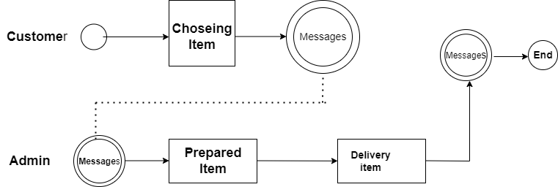

Figure 3.1: BPM

At first, a customer chose the item and it add to card then admin will get the message and admin check product details, it is available in-store if this product is available in store then admin prepared item and will be delivered item to customers.

* 1. **Use Case Modeling and Description**

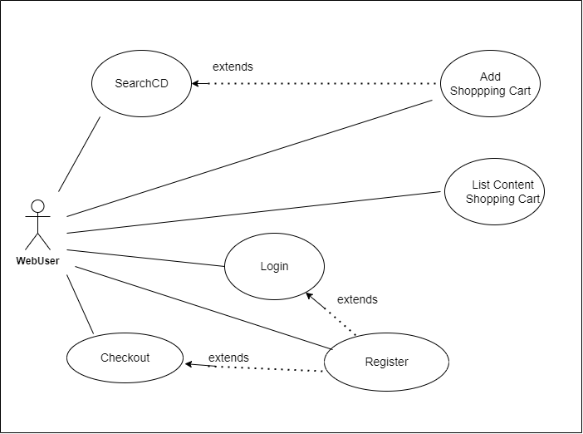

This use-case diagram is very simple. Confirm web user registration then login with appropriate username and password. After logging in, a user can access our web site. He will then select any product and add shopping cart then check out. Product Manager Deliver the product to the customer.

**CHAPTER 4**

**SPECIFICATION**

* 1. **Front-End Design**

Will show a user at beginning of our application Front-end interface and see every product but they can not purchase any product, assuming that he has a record he can sign in utilizing the email and secret key he gave. On the off chance that they don't have a record, they go to sign up page and given required data in the field. When a customer signs in, they will see a landing page and an add-to-button option at the bottom of each product. They can be select each product according to their wishes via the Add to Card button. Once selected, each product will be added to the order cart, customers will check to confirm the order of their product. Finally the customer checks out his order.

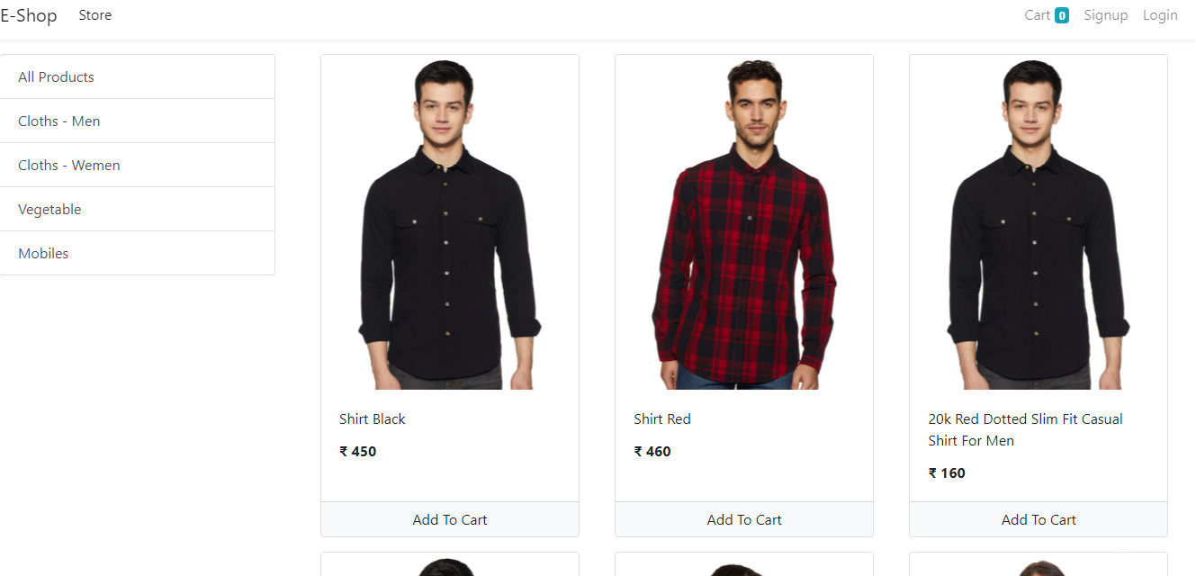

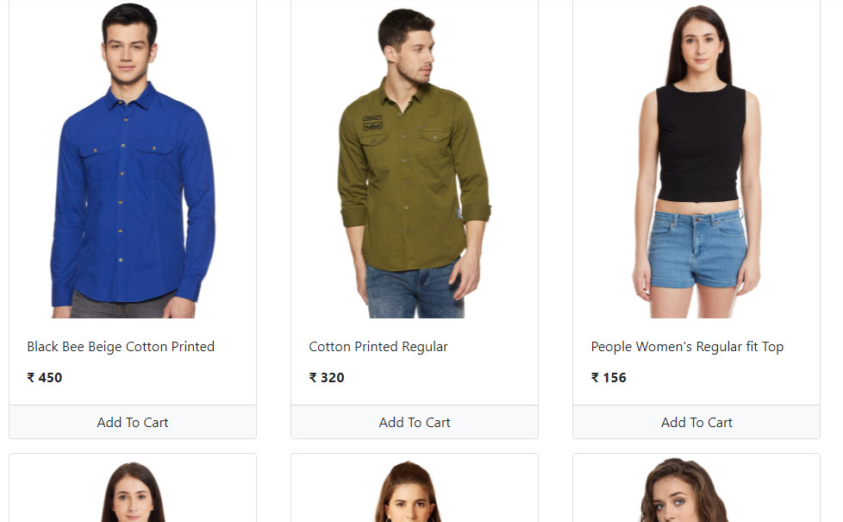

Figure 4.1: Front-End Design

First of all, we make a perfect plan for our e-shop user-interface design. We are using bootstrap, Django framework, front style, html5, css3 also Django database. It's planned to provide good looks to our frontend page.

**Login-Page:**

After logging in, every user will be able to purchase our e-shop products. For login, email and password must be matched in existing email and password in database when customer sign up.

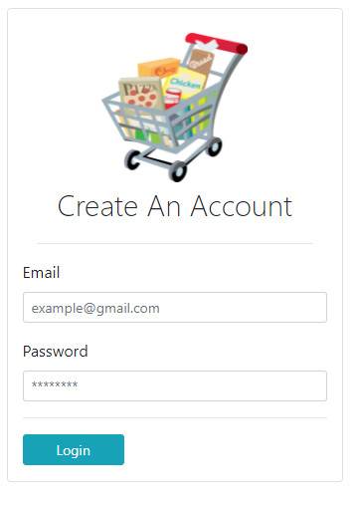

Figure 4.1.1: Log-in Page design

**Signup-Page:**

You must sign up before logging in, and the email address for signing up must be unique.

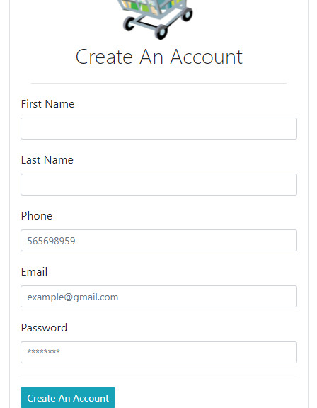

Figure 4.1.2: Sign up Page design

**Order-Cart:**

Everyselected product will be added to the order cart. Customers will see their total selected product price. Suppose customers add to the cart five products they can see total five product prices in the card option also see single product details.

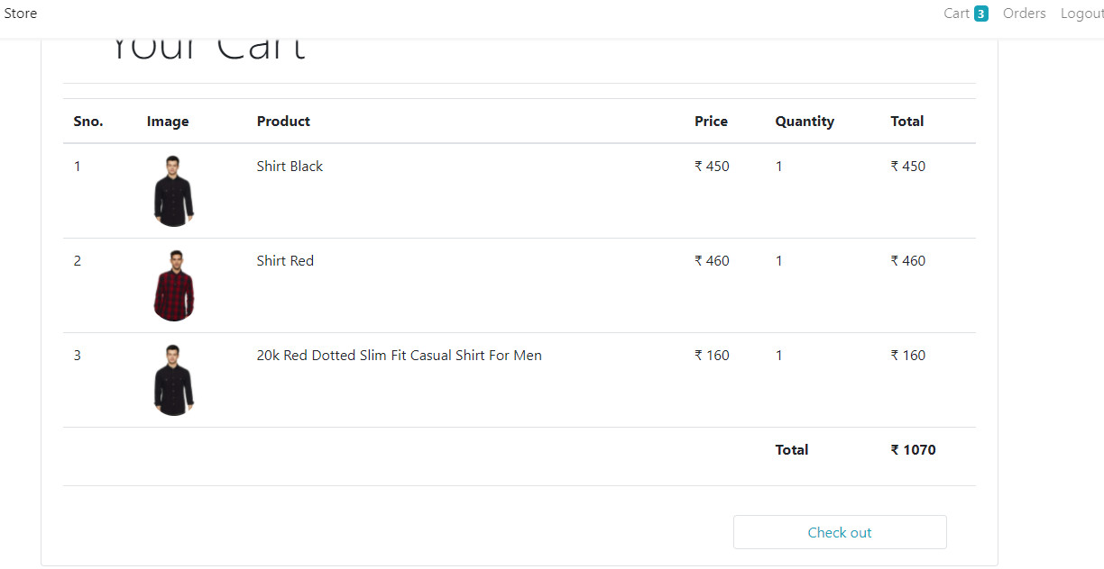

Figure 4.1.3: Customers product cart list

**Customers Order:**

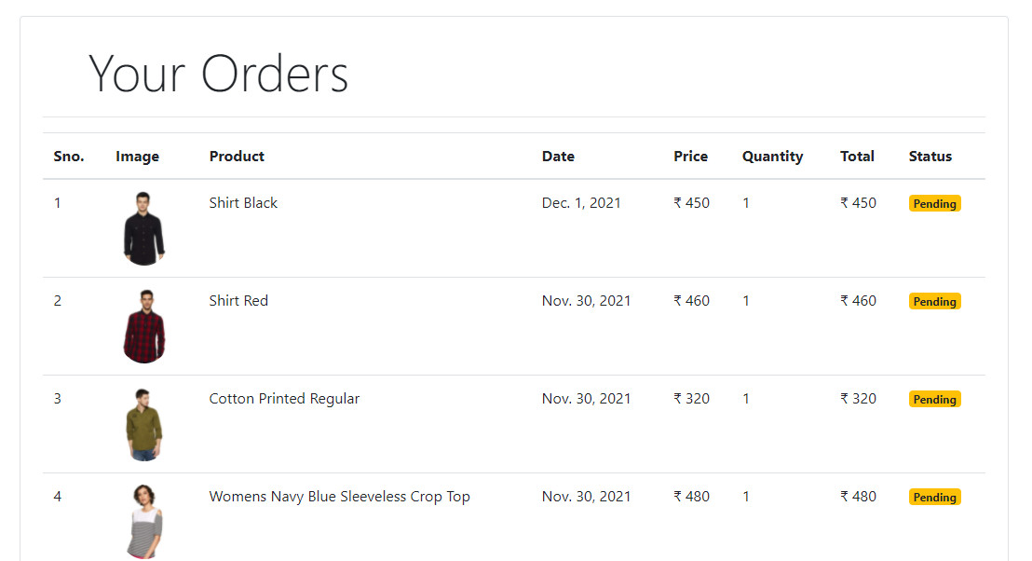

Figure 3.1.4 : Customer orders pending list

Here, customer can show their order list are pending. It is unique facilities in our website. User very comfortable seeing this feature. Because this feature is not available another website. When customers get their product on hand then they are not see pending it must be active or done.

**4.2 Back- end Design**

Admin maintains the entire website through the admin panel. Admin can add many users for maintains various sections in our website and also remove users accordingly his wishes.

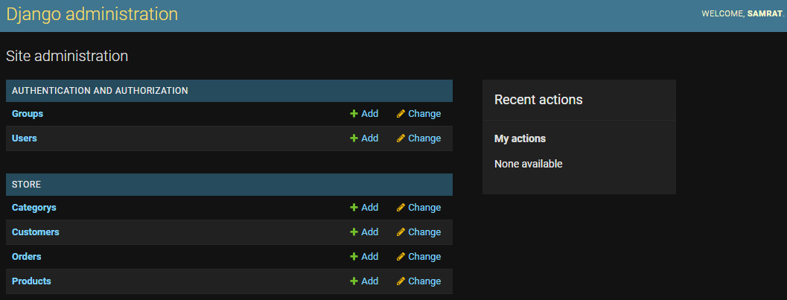

Figure 4.2: Admin panel

**Add Product:**

Admin can add product and add product details by using name field admin gives product name, using price field admin gives product price, using category field admin gives product category, using description field admin gives product details, using image field admin gives product photos. Admin can also edit uploaded product details and save it.

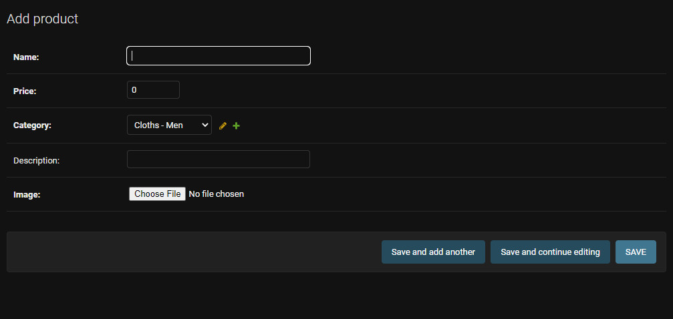

Figure 4.2.1: Add to product in Back-end

**Add Category:**

Amin can create a new category for new item product and also can edit existing category.

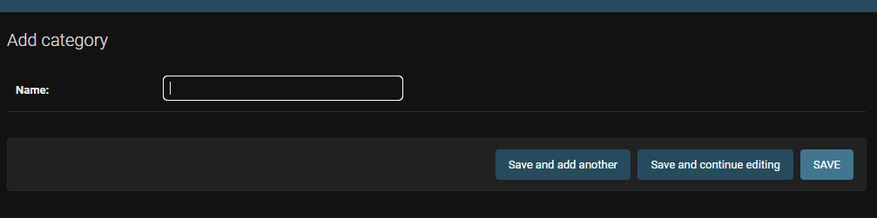

Figure 4.2.2: Add a category in Back-end

**Add order:**

Admin can see customer order details

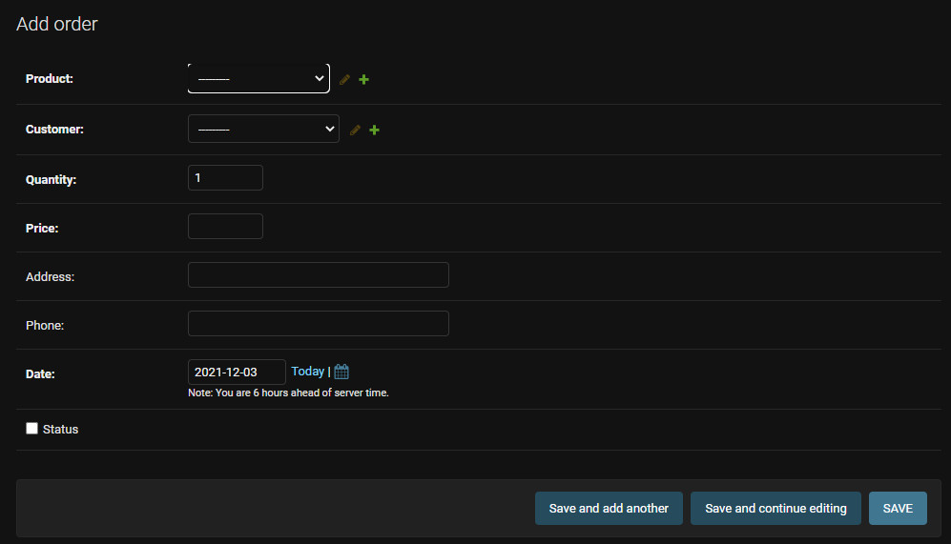

Figure 4.2.3: Add order in Back-end

* 1. **Interaction Design and UX**

First of all, we make a perfect plan for our e-shop user-interface design. We are using bootstrap, Django framework, front style, html5, css3 also Django database. It's planned to provide good looks to our frontend page. Customers will have selected their product easily in design and unselected product. We will able to develop a design in the future.

* 1. **Implementation of Requirements**
* We need to python language for our project to implement
* Need to Django framework knowledge
* Database is Default db.sql in Django
* The hosting platform must be a Windows-based server
* We need javascript,css3, bootstraps for frontend implementation
* Need vs code for coding or use a different editor

**CHAPTER 5**

**IMPLEMENTATION AND TESTING**

* 1. **Implementation of Database**

We can take help from default Django Database to project implementation

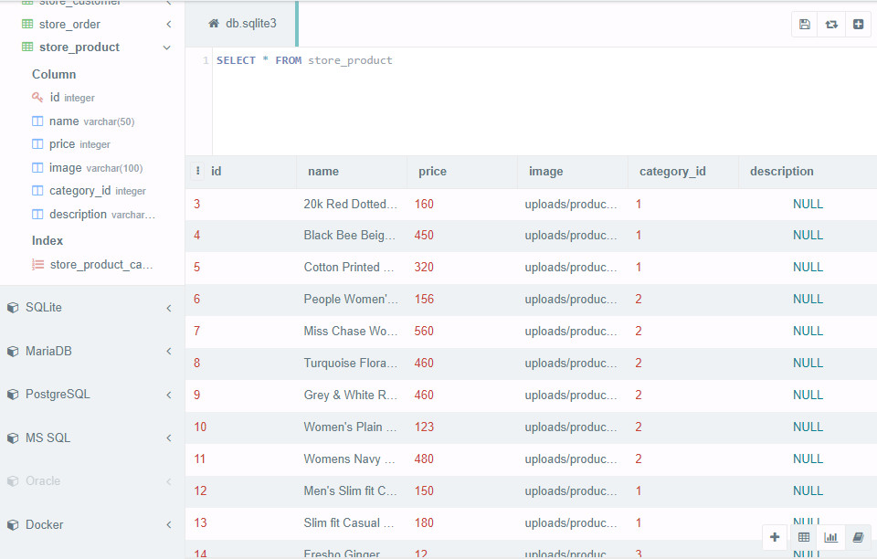

Figure 5.1: Database

* 1. **Implementation of Font-end Design**

Login implementation code:

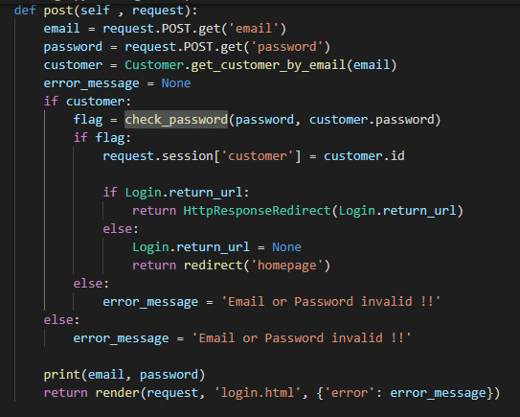



Sign up implementation code:

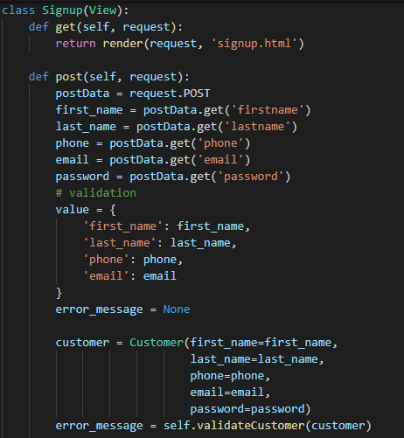



* 1. **Testing Implementation & Result**

If email and password does not match you can not login.

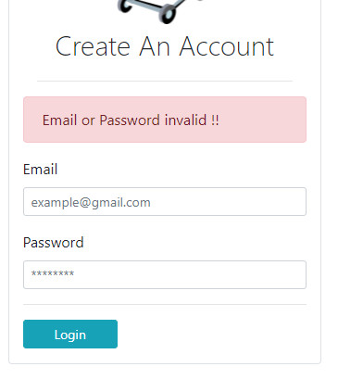

In sign up page First name and Last name must be 4 char long or more. If Email Address Already Registered, you must be require unique Email. Password must be 6 char long.

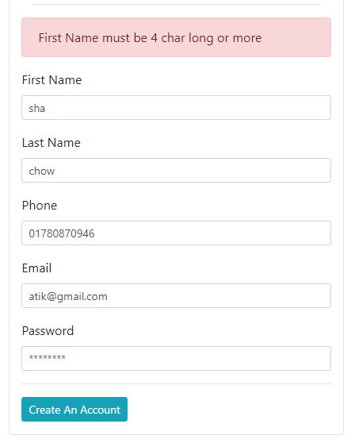

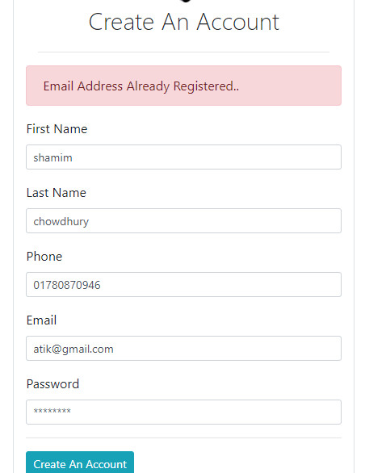

**CHAPTER 6**

**IMPACT ON SOCIETY, ENVIRONMENT AND SUSTAINABILITY**

**6.1 Impact on Society**

An e-shop website is essential in our digital world. This e-shop creates more workplaces that's why help us to reduce our unemployment. Our government can charge tax when a customer will buy a product. Therefore increase our country revenue. If we build the biggest e-shop platform and store unique products, Foreigner people will be interested to order then we can earn foreign revenue

This application will give open positions, so it will eliminate joblessness issues for a specific reason. Therefore the crime percentage will reduce, On the grounds that numerous wrongdoing happiness just for the case. At the point , they will get workplace they will leave this false way.

**6.2 Impact on Environment**

* Finally, more online shopping means more carbon emissions and a greater environmental impact This reduces their carbon emissions because it is more efficient than online order which is low volume.

**6.3 Ethical Access**

Profound quality is the arrangement of moral rules that oversees an individual's conduct or movement. This task was morally right and keeping in mind that the application will be utilized by the clients, the moral activities won't be abused under any conditions.

Here are some common occurrences of ethical violations on e-shop websites:

* + - * False products
      * lately delivery
      * Wrong product delivery
      * Own product counterfeit bidding
      * Date over product

### 6.4 Sustainability Plan

### Sustainable planning is an important. We have to follow some rules:

### Target large number of users

### Consider the largest demand of users

### Reduce cost

### Promotion in the market for grow your business

### Look for opportunities to grow.

### Mapping area to improve there

### CHAPTER 7

### CONCLUSION AND FUTURE SCOPE

### 7.1 Discussion and Conclusion

### WEB-BASED e-shop is a challenging project because it's a new idea. At starting we didn't know how the interface would be. Thought it's challenging to build up a new project, we have built it.

### 7.2 Scope for further Developments

### We want the future that others want to make our business bigger, That is why we need proper planning to consider our society’s situation. If we added international shopping cards(master card) in our e-shop and store unique products, Foreigner people will be interested to order then we can earn foreign revenue.

Thank You!

Best of Luck

